**RIP AND OSPF PROTOCOLS**

**ROUTING INFORMATION PROTOCOL**

**AIM**

To simulate Routing Information Protocol using Cisco Packet Tracer

**THEORY:**

RIP stands for Routing Information Protocol. RIP is an intra-domain routing protocol used within an autonomous system. Here, intra-domain means routing the packets in a defined domain, for example, web browsing within an institutional area.

* RIP is based on the distance vector-based strategy, so we consider the entire structure as a graph where nodes are the routers, and the links are the networks.
* In a routing table, the first column is the destination, or we can say that it is a network address.
* The cost metric is the number of hops to reach the destination. The number of hops available in a network would be the cost. The hop count is the number of networks required to reach the destination.
* In RIP, infinity is defined as 16, which means that the RIP is useful for smaller networks or small autonomous systems. The maximum number of hops that RIP can contain is 15 hops, i.e., it should not have more than 15 hops as 16 is infinity.
* The next column contains the address of the router to which the packet is to be sent to reach the destination.
* In RIPv1 routers broadcast updates with their routing table every 30 seconds. In the early deployments, routing tables were small enough that the traffic was not significant. As networks grew in size, however, it became evident there could be a massive traffic burst every 30 seconds, even if the routers had been initialized at random times.
* RIP uses the user datagram protocol (UDP) as its transport protocol, and is assigned the reserved port number 520.

**PROCEDURE:**

1.Download the Cisco Packet Tracer and Login,then open a new Window.

2.Select two End Devices(2 PC’S) and Drag them from the menu.

3.Select two Network Devices(PT routers) and two Switches (PT Switch) and Drag them from the menu.

4.Connect All of them as shown in the output.

5.Name the two networks as A and B and assign them a particular IP address.

6.Configure the two End Devices using the IP address assigned.

7.Similarly assign the IP address between the two connected Routers.

8.Send the Packet PC0 to Router0 and Similarly between PC1 to Router1.

9.Now try to send the packet between PC0and PC1,if it fails go to step 10.

10.Configure the Routers and add all the IP address to the RIP of Routers and save them.

11.Now send the packets from PC0 to PC1 and from Router0 to Router1.

12.The Packets are being successfully sent.

**OUTPUT SCREENSHOTS**

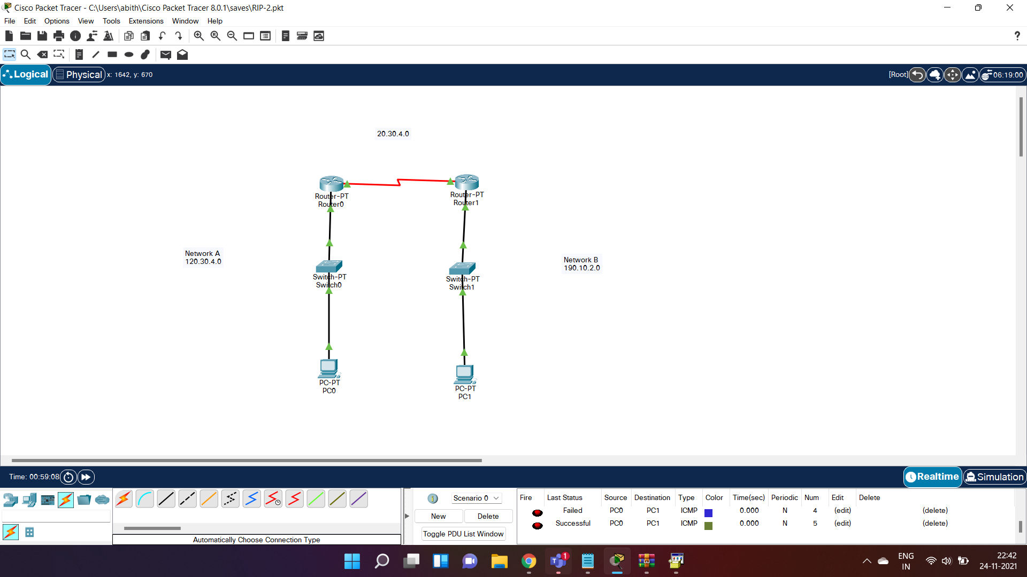



**RESULT**

Hence Routing Information Protocol is simulated and the packet is successfully sent from the PC0 to PC1 and vice versa

**OPEN SHORTEST PATH FIRST PROTOCOL (OSPF)**

**AIM**

To simulate the Open Shortest Path First Protocol (OSPF) in Cisco Packet Tracer

**THEORY**

Open Shortest Path First (OSPF) is a link-state routing protocol that is used to find the best path between the source and the destination router using its own Shortest Path First). OSPF is developed by Internet Engineering Task Force (IETF) as one of the Interior Gateway Protocol (IGP), (i.e), the protocol which aims at moving the packet within a large autonomous system or routing domain. It is a network layer protocol which works on

OSPF uses multicast address 224.0.0.5 for normal communication and 224.0.0.6 for update to designated router(DR)/Backup Designated Router (BDR).

Every router contains the same information about the network. The way the router learns this information by sending LSA (Link State Advertisements). These LSAs contain information about every router, subnet, and other networking information.

Once the LSAs have been flooded, the OSPF stores the information in a link-state database known as LSDB. The main goal is to have the same information about every router in an LSDBs

**PROCEDURE:**

1.Login Cisco Packet Tracer and Open a new Window.

2.Drag in two PC’S from the End Devices.

3.Drag in Three Routers and Connect all the Devices.

4.Name the networks with appropriate IP address.

5.Configure the PC’S to their respective networks.

6.Connect the Routers in their appropriate Networks.

7.Now use the OSPF to make all the networks visible to each other.

8.See the Serial Routers are Connected it and Configure them.Use the Command line Interpreter to activate the OSPF.

9.Enable and Configure the terminal in the CLI.

10.Now Connect the Router to the Networks it is Connected.

11.The OSPF is activated hence making all the networks visible to each other.

12.Now send a Packet from PC0 to PC1 and Vice versa, the Routers choose the path to deliver the packet.

**PROGRAM CONFIGURATION**

**ROUTER0 OSPF CONFIGURATION**

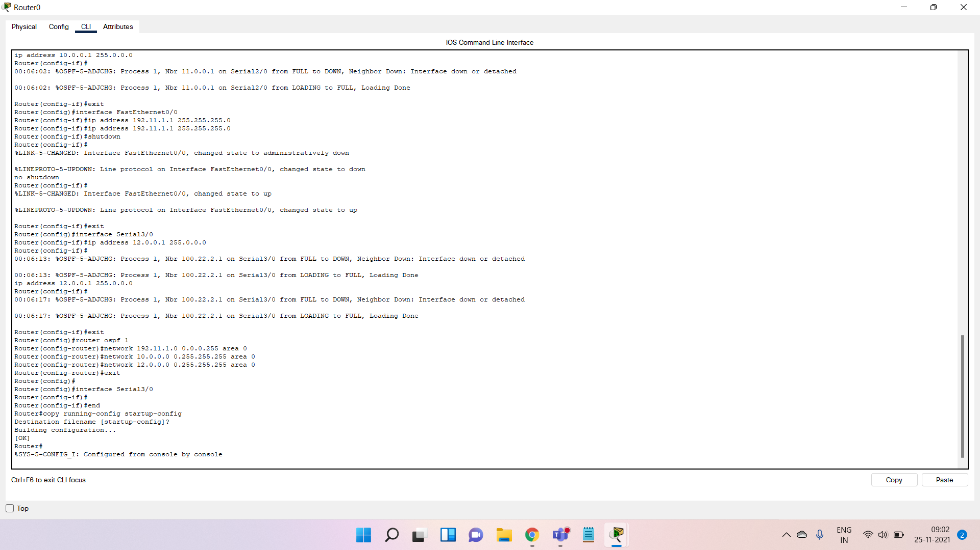

**ROUTER1 OSPF CONFIGURATION**

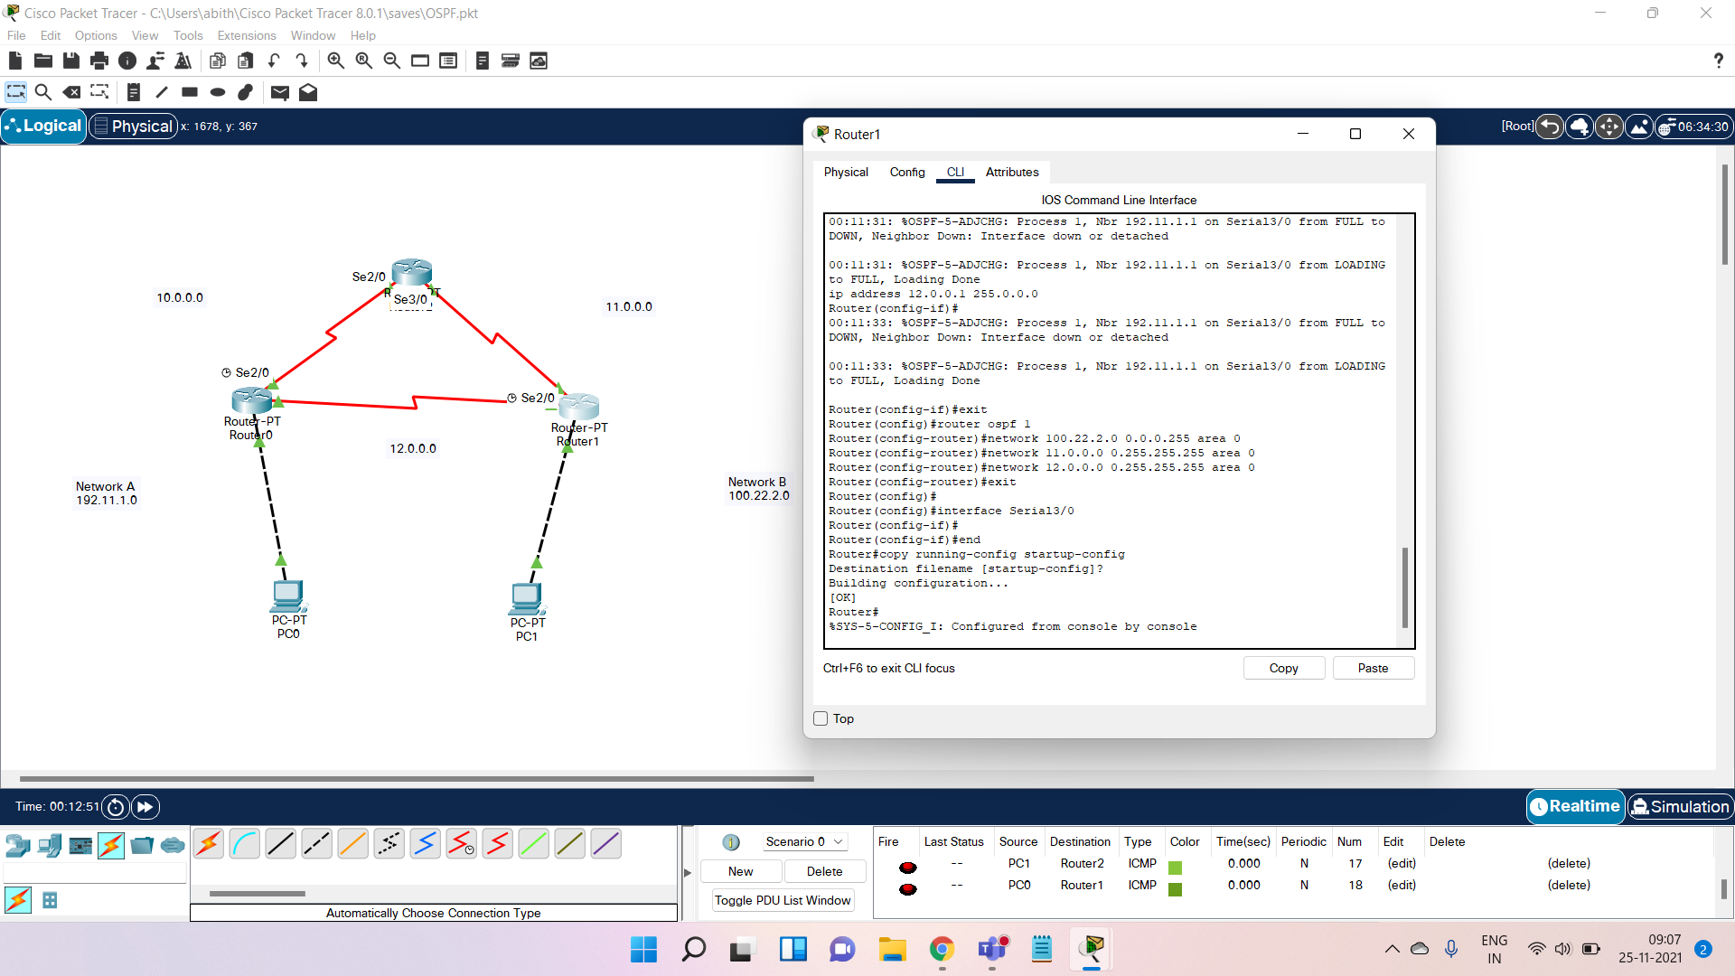

**ROUTER2 OSPF CONFIGURATION**

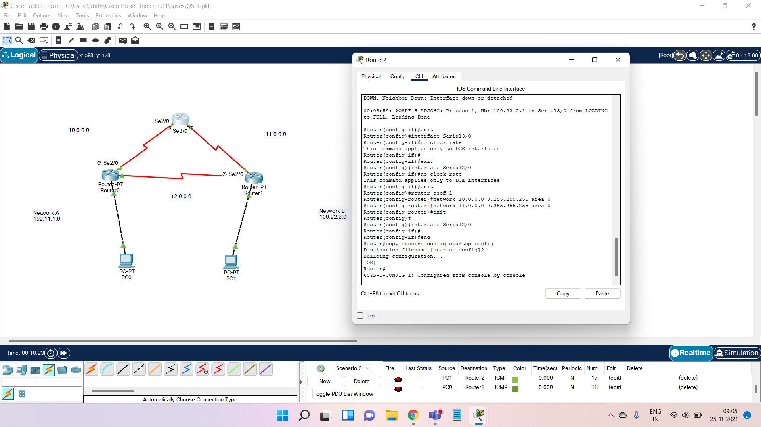

**OUTPUT SCREENSHOT**

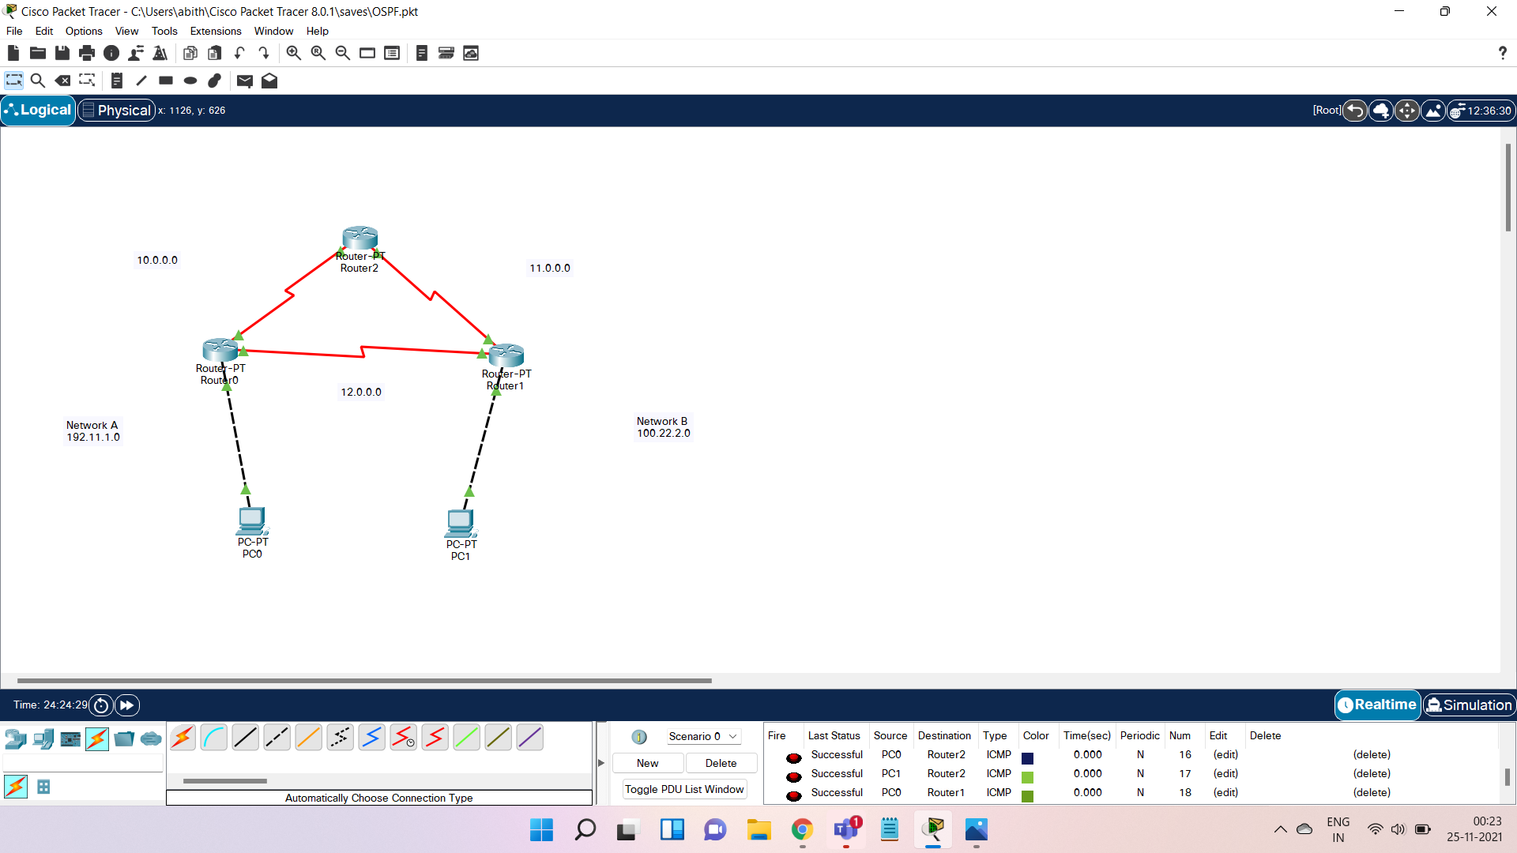



**RESULT**

Hence Open Shortest Path First (OSPF) is simulated and the packet is successfully sent from the PC0 to PC1 and vice versa